In the world of software development, choosing the right database is a crucial decision that can significantly impact your application's performance, scalability, and ease of use. With many options available, it can be challenging to determine the best database management system (DBMS) that will perfectly suit your needs.
In this article, we’ll compare the 12 most commonly used DBMSs: MySQL, MariaDB, Oracle, PostgreSQL, MSSQL, SQLite, MongoDB, Redis, Cassandra, Elasticsearch, Firebase, and DynamoDB. We will focus on their business-related benefits and challenges while highlighting the ideal use cases for each. With this database comparison at hand, you will be able to make an informed decision for your project.

What is a database management system?
A Database Management System (DBMS) is a specialized software designed to store, retrieve, and manipulate data. It acts as a mediator between the database, applications, and user interfaces to manage and organize data effectively. The system provides a comprehensive suite of tools to govern databases, ensuring data security, consistency, and integrity.
A DBMS supports various applications, from simple storage and retrieval tasks to complex data-driven systems, by implementing efficient data access and management practices. Additionally, the system can handle concurrent users, maintain transactional consistency, and provide robust backup and recovery options, making it an essential component in any data-centric environment.
Since databases are just a part of the whole data management strategy, learn about this comprehensive approach in our dedicated article. Also, read our article on master data management.

Types of databases: Relational vs non-relational
There are two types of DBMSs: relational and non-relational, also referred to as SQL and NoSQL respectively. Before discussing the most popular database options, let’s take a closer look at how relational and non-relational database systems differ, considering commonly used data structures, performance, scalability, and security.
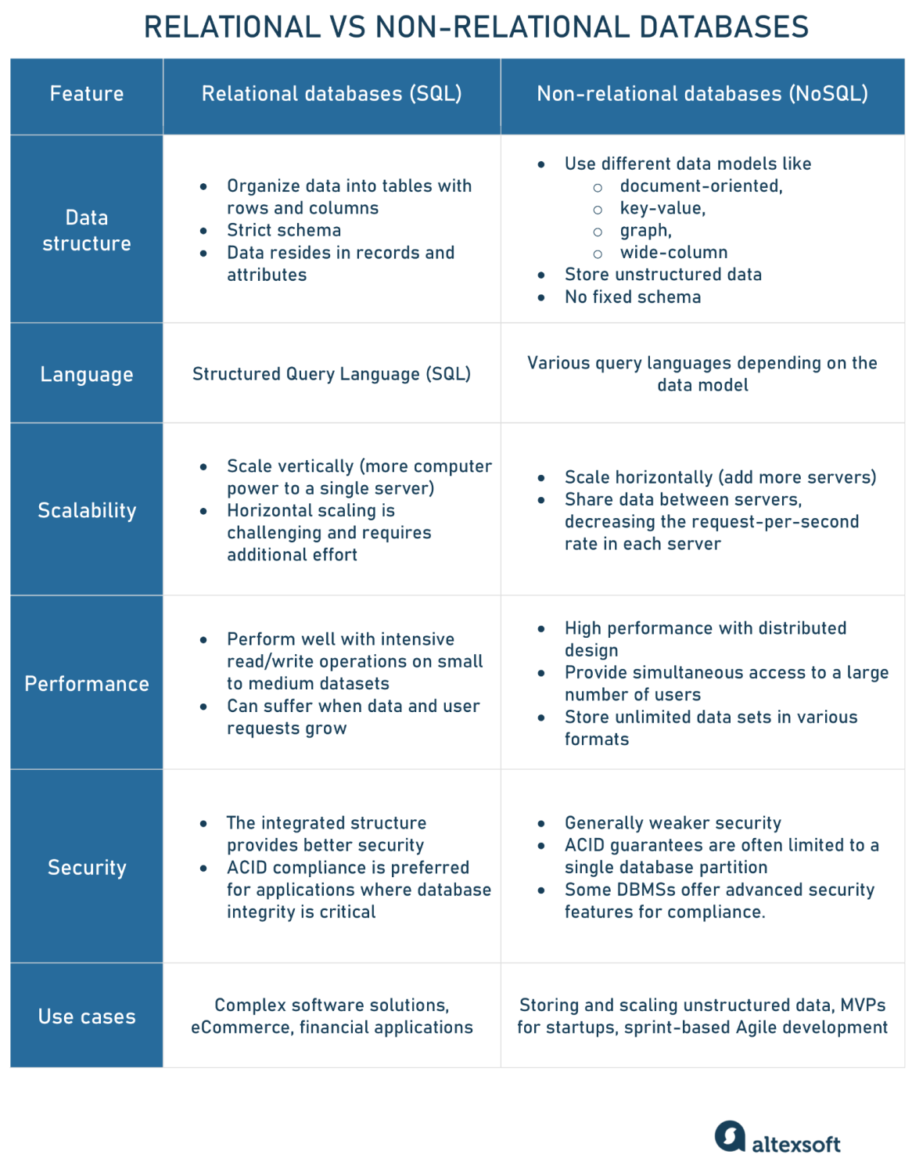
Relational vs non-relational databases in a nutshell.

Relational or SQL databases
A relational database management system (RDBMS) is an information repository that organizes data into tables consisting of rows (records) and columns (attributes that contain the properties of these records). Each table represents a relation, and the rows (also called tuples) hold individual records within that relation. RDBMSs have a predefined schema with a strict structure and clear dependencies between different data points.
So tables in relational databases are connected to other tables through primary key or foreign key relationships. A primary key is a unique identifier for each record in a table, ensuring that no two records have the same value for that specific column or set of columns. On the other hand, a foreign key is a column or a set of columns in one table that refers to the primary key in another table, establishing a link between them.
Despite these connections between tables, the term relational in relational database systems comes from the mathematical concept of relations. Dr. Edgar F. Codd proposed this idea as a new way to organize and manage data using principles from mathematics in his seminal paper "A Relational Model of Data for Large Shared Data Banks," published in 1970.
The second name of such systems is SQL databases. This is because Structured Query Language (SQL) is used to communicate with and manage these databases.
Scalability. Relational databases usually scale vertically, meaning data lives on a single server, and scaling is done by adding more computer (CPU, GPU, and RAM) power to that one server. However, switching from smaller to bigger machines often involves downtime. Scaling an SQL database between multiple servers (horizontal scaling) can be challenging as it requires data structure changes and additional engineering efforts.
Performance. Relational databases perform well with intensive read/write operations on small to medium datasets. They also offer improved speed of data retrieval by adding indexes to data fields to query and join tables. However, the performance may suffer when the amount of data and user requests grows.
Security. Due to the integrated structure and data storage system, SQL databases don’t require much engineering effort to render them well-protected. They are a good choice for building and supporting complex software solutions where any interaction has a range of consequences. One of the SQL fundamentals is ACID compliance (Atomicity, Consistency, Isolation, Durability). ACID-compliance is a preferred option if you build, for instance, eCommerce or financial applications where database integrity is critical.
Since business applications are most often written in program-oriented languages, developers need to synchronize relational databases and objects in the code. It's done through ORM (object-relational mapping). To learn more, read our dedicated article.

Non-relational or NoSQL databases
A non-tabular or non-relational database uses different data models for storing, managing, and accessing data. The most common data models are
- document-oriented — to store, retrieve, and manage data such as JSON documents;
- key-value — to represent data as a collection of key-value pairs, where keys are unique strings having corresponding data values;
- graph — to store data in the node-edge-node structure where nodes are data points and edges are their relationships; and
- wide-column — to store data in the tabular format with flexible columns, meaning they can vary from row to row in the same table.
As these databases aren’t limited to a table structure, they are called NoSQL. They allow for storing unstructured data such as texts, photos, videos, PDF files, and a bunch of other formats. Data is simple to query but isn’t always classified into rows and columns as in a relational database.
Scalability. When the number of data and requests increases, non-relational or NoSQL databases are usually scaled horizontally by adding more servers to the pool. They share data between various servers where each contains only a part of the data, decreasing the request-per-second rate in each server.
Performance. Non-relational databases are known for their high performance: They have a distributed design, which lowers the performance load on the system and provides a large number of users with simultaneous access. Such databases can store unlimited data sets that come in all types and shapes. They are also quite flexible when it comes to changing data types.
Security. Unlike relational systems, NoSQL databases have weak security, making them a major concern for many infrastructures. While they may provide ACID guarantees, they are typically available within the scope of one database partition. However, some DBMSs offer advanced security features that meet strict security and compliance standards.
Since NoSQL databases allow for reserving various data types together and scaling across multiple servers, their never-decreasing popularity is understandable Also, NoSQL databases can be highly advantageous when it comes to building an MVP. They don’t require pre-deployment preparations, making quick, time-lag-free updates to the data structure easier.
Read our article about types of databases and database management systems. The overview will help you understand which database might be best for your needs and why.
So what are the most commonly used database systems in SQL and NoSQL? What are their main advantages and disadvantages, and how should businesses use them? Let’s take a deeper look.
Below, we’ll discuss the following list of SQL databases:
- MySQL
- MariaDB
- Oracle
- PostgreSQL
- MSSQL
- SQLite
and will complement it with such NoSQL databases as:
- MongoDB
- Redis
- Cassandra
- Elasticsearch
- Firebase
- Amazon DynamoDB
The screenshot below reflects the popularity of these and a few other databases.
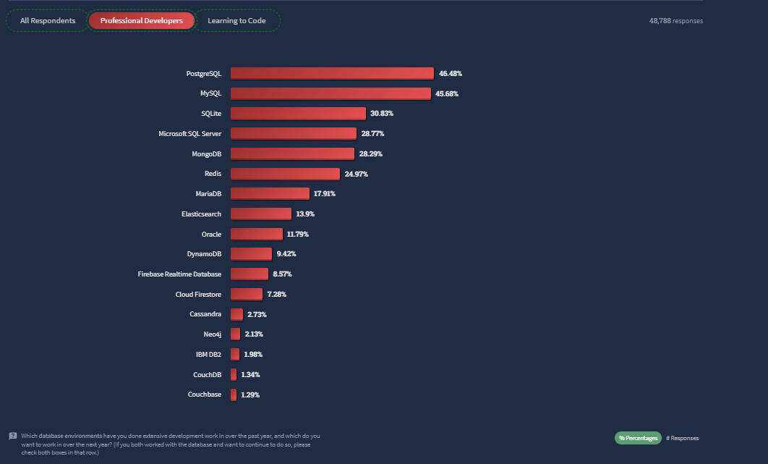
Most popular database systems. Source: 2022 Developer Survey by StackOverflow
While more detailed descriptions of the aforementioned databases await you further in the post, the table here provides a quick-look comparison against key criteria.
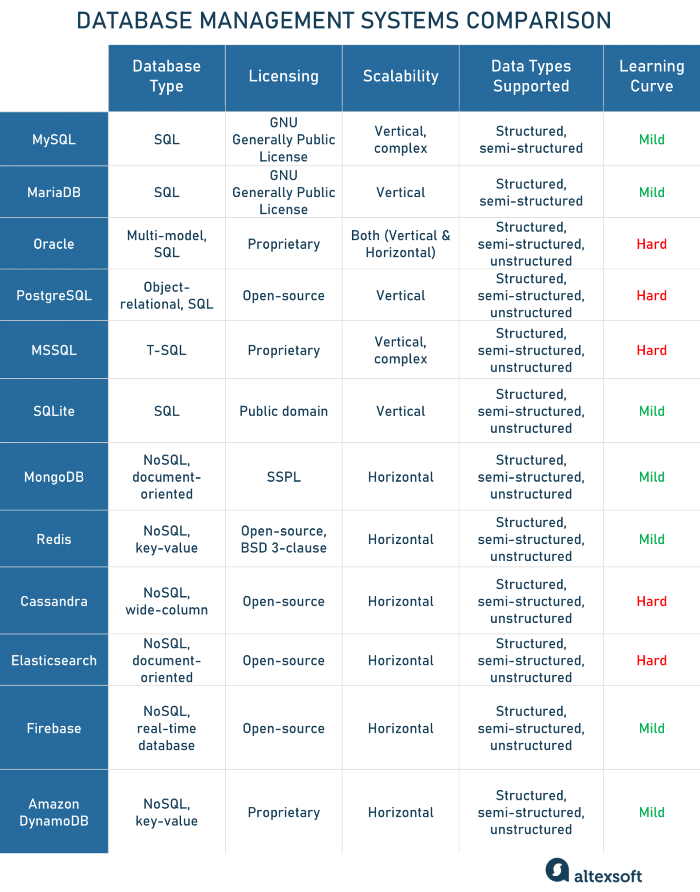
Database management systems comparison.

